2012-2013 ACADEMIC YEAR AYŞE FİTNAT SECONDARY SCHOOL
FIRST TERM SECOND ENGLISH EXAMINATION FOR 8TH GRADES
Name / Surname: Class / Number :
A. Fill in the blanks with “too” or “enough”. (5x2=10)
- The soup is ________ salty to drink. 4. It’s light ________ to lift.
- He is clever ________ to pass the exam. 5.The weather is _______ hot to go out.
- 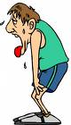 He is _________ tired to run fast.

B.Categorize the words below. (8x2=16)
Shampoo Acne Jel Comb Hand Cream Shower Gel Nail Clipper Stick Deodorant Body Lotion

Hand Care Products | Hair Care Products | Body Care Products | Skin Care Products

C.Use should or shouldn’t and circle it. (5x2=10)
1– If you want to get rid of acnes on your face , you should / shouldn’t us acne jel.
2 – You should / shouldn’tplay computer games too much. It is harmfulfor your eyes.
3 – Your skin is smooth enough . You should / shouldn’tuse any care products.
4 – You should / shouldn’t eat fruit and vegetable. They are healthy.
5 – You should / shouldn’t brush your teeth three times a day.
D. WHEN / WHILE (5x2=10)
1. ____________ he was doing homework, it began to rain.
2. ____________ she crashed the car she was sleeping.
3. They were having picnic ____________ it stopped shining.
4. You were knitting _____________ I entered.
5. She met her sister ______________ she was walking in the park.
E. Write the dates. (5x2=10)
1. 12th March , 2002 : …………………………………………………………
2 .28th November, 1970 : …………………………………………………………
3. 29th October, 1923 : ………………………………………………………..
4. 21st June , 1965 : ………………………………………………………
5. 23th April , 1920 : …………………………………………………………

F) Choose the correct answer! (15x3=45)
1)How often do you brush your teeth?
a) yesterday b) now
c) once a day c) in the morning

2) “I have got some dreadful acne on my
face.I can’t get rid of it.Furthermore,
I am plump because I eat too much. I
can’t help eating chocolate, a packet of
biscuits or crisps. I’m fat and ugly.”

Konuşmayı yapan kişi seçeneklerden hangisidir?
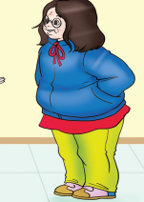
a) b) c) d)

3) Which sentence is about personality?
a) I am plump because I eat too much.
b) I think I am too tall
c) I can’t see myself as a beautiful girl
d) I have got lots of friends, because I have a good sense of humour

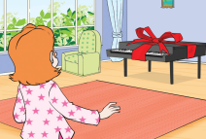
4) She was so excited with the piano that she couldn’t notice the guests.
They were clapping, singing
the birthday song.
She said ……………………………………… .
a) ““Never thought I’d see you here!”
b) “Shouldn’t you be in your bed?”
c) “I can’t believe in my eyes!”
d) “Fancing meeting here!”

5) When I called my father,He ………………fish.

a) caught b) were catching
c) was catching d) catches

6) He …………… from the Academy in 1905 as
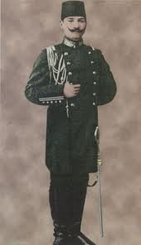
a captain.
a) graduated b) started
c) attended d) defended

7) Choose the correct order.

I.M. Kemal Atatürk was born in Salonica in 1881
II.Then, he went to the Military School.
III.First, he went to Şemsi Efendi Primary School.
IV.He was the commander of Independence War.

a) I – II – IV –III b) I‐ IV – III – II
c) III – IV – I – II d) I – III – II – IV
8)Yahya Kemal’in söylediği bu sözü en iyi
açıklayan seçenek hangisidir?
People can live as long as they dream.

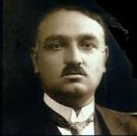
YAHYA KEMAL BEYATLI

- People can’t live without dreams and hopes. If they dream and hope, they will be happy.
- I dream my paintings and then paint my dream.
- Dream as if you’ll live forever; live as you’ll die today.
- “When we are dreaming alone, it is only a dream. When we are dreaming with others, it is the beginning of reality.

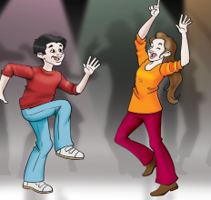
9) Look at the picture and find suitable
surprise statement?
- “Shouldn’t you be in school?”
- “Good heavens!”
- “What a nice surprise to see you here!
- “You’re joking.”

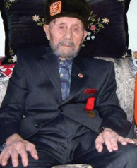
10) S1: Who is Yakup Satar?
S2: ……………………………… .
- He is a policeman
- He is a commander
- He is an officer
- He is a veteran
11) Murat Boz is a ________ singer. He sings ________. a) good / good b) good / well
c) well / good d) better / good
12)Two countries wanted to end the war.They decided to

……………………a peace………………………
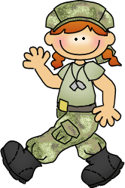
a)sign/treaty b)attack/treaty
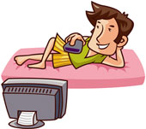
c)fight /battle d)attack/enemy

13) When she ____home, he ____t.v.
- was coming /watched c) is reading / is watching
- came / watches d)came / was watching
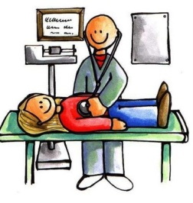
14) I have some _____________; I’m
dreaming of being a doctor.
a) goals b) problems
c) advantages d) products

15) I had a weird dream last week.
I …………….an astronout and I……………………………..in the space.

a)was/was flying b)were/were flying
c)was/flying d)were/were
Tuğba ÇAĞLAR
GOOD LUCK

