***2012-2013 EDUCATION YEAR 1st TERM 1st ENGLISH EXAM FOR 7th GRADE AYŞE FITNAT PRIMARY SCHOOL***

*Name/Surname: Number: Class:7/ C MARK:*

**A) Boşluklara resimlerde verilen burçları yazınız. Pisces –Aries –Cancer – Libra – Sagittarius**

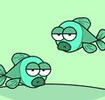  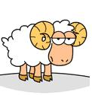 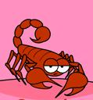 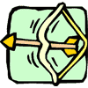

1).……………... 2)……………… 3)……………….. 4)……………... 5)……………..

**B) Verilen sıfatları “physical” ve “personality” olmak üzere gruplandırınız.**

**selfish - thin – helpful – handsome – rude – beautiful – fat – funny – generous - tall –**

|  |  |
| --- | --- |
| Physical Appearance | Personality |
| 1.  2.  3.  4.  5. | 1.  2.  3.  4.  5. |

**C)PARÇAYI OKUYUN VE BOŞLUKLARI DOLDURUN.**

[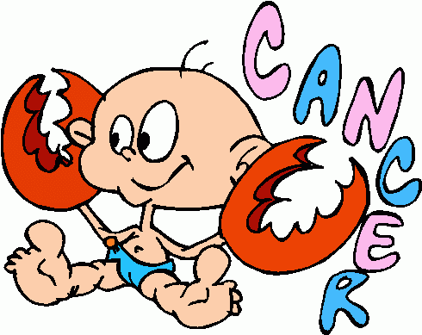](http://www.myfreegraphics.com/View/Horoscope_Signs/Cancer/Cancer_3)

Your element is Water and your planet is the Moon.Your Stone is Moonstone.Your colours are orange,silver and white.You are sensitive and kind.You like collecting things.You don’t like losing things.Your opposite sign is Capricorn and you are compatible with Pisces.

[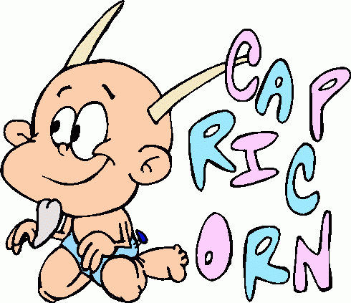](http://www.myfreegraphics.com/View/Horoscope_Signs/Capricorn/Capricorn_3)

Your element is Earth and your planet is the Saturn.Your Stone is Turquoise.Your colours are orange,sil dark gren and brown.You are careful and hardworking.You like talking friends.You don’t like lazy people.Your opposite sign is Gemini and you are compatible with Virgo.

|  |  |  |
| --- | --- | --- |
|  | CANCER | CAPRICORN |
| Characteristic |  |  |
| Likes |  |  |
| Dislikes |  |  |
| Lucky colours |  |  |
| Opposite signs |  |  |
| Compatible with |  |  |

**D) HOLIDAY TYPES: CAMPING/SKIING/SAFARI/RAFTING/TREKKING**

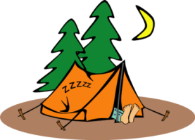 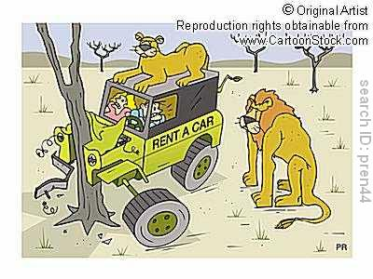 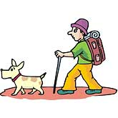[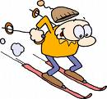](http://images.google.com.tr/imgres?imgurl=http://www.gnurf.net/v3/wp-content/uploads/2008/04/030-downhill-skiing.png&imgrefurl=http://www.gnurf.net/v3/clip-art/free-clip-art-downhill-skiing-030.html&usg=__5gjcJ2bLFpnFHeMt_TYM2eio_fQ=&h=466&w=500&sz=69&hl=tr&start=2&um=1&tbnid=gY1AX5vZI5R4nM:&tbnh=121&tbnw=130&prev=/images?q=skiing++cartoon&hl=tr&um=1)

1)……………… 2)………………. 3)…………………..… 4)……….……. 5)…..……….

**E) Aşağıdakileri haritaya göre doldurunuz.**

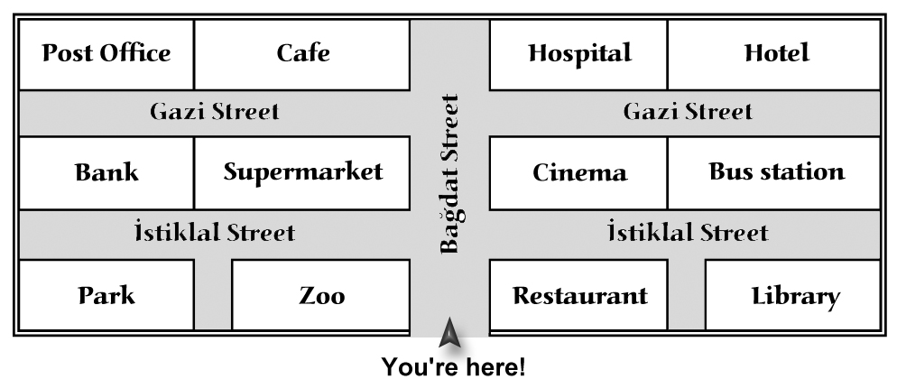

**1)**Aşağıda verilen yol tarifi bizi nereye

götürüyor?

“ Go along the Bağdat Street. Turn right.

It is next to the hotel.

a-)bus station b-)hospital

c-)cinema d-)supermarket

**2)**Aşağıda verilen yol tarifi bizi nereye

götürüyor?

“ Go straight ,turn left.It is on your

left.It is at the end of the İstiklal

street.”

a-)bank b-)zoo

c-)park d-)restaurant

**3)** Go up the street . You see Gazi Street. Turn

left. It is on the ______, next to the café.

**4)** A: _______ can I go to the PARK?

B: Go up the street.Turn left and

go along.

Park is __________ the zoo.

**5)** A :___ you tell me the way to the Hotel?

B: Go up the street. You see Gazi street.

_____ right . Go straight ahead

Hotel is _______the hospital.

|  |
| --- |
| **Note: Each question is 2,5 points** |

**Good Luck☺ Tuğba ÇAĞLAR**