

**2012-2013 EDUCATION YEAR HATİCE ATŞE FITNAT SECONDARY SCHOOL**

**7th GRADE 1ST TERM 2nd WRITTEN ENGLISH EXAM**

**Name and Surname: Class: 7/ Number: MARK:**

AverellWilliam **Jack Joe**

**A) Compare the Dalton brothers. COMPARATIVE---SUPERLATIVE(3x5=15pts)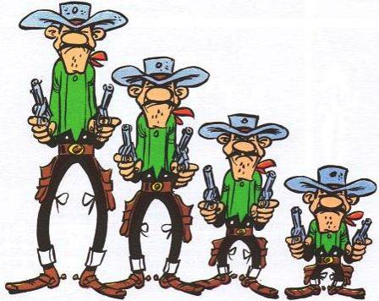**

**1**. Averell …………………….....................…….................................…of all. (tall)

2 Joe …………..............................……………….............................of all. (old)

3. William ……..............................…........……….............…...… Joe. (young)

4.Joe ...................................................................................Averell. (old)

5.Jack....................................................................................of all (young)

37

23

33

24

**B. Put a tick under the correct column. (3x7:21)**

1.You can get information easily and fast. BD21298_ ……………… ………………

2.You can pay the bills. BD21298_ ……………… ………………

3.There are harmful websites. BD21298_ ……………. ………………

4.You can play games. BD21298_ ……………. ………………

5.There is a risk of radiation. BD21298_ ……………… ………………

6.There is false information. BD21298_ ………………. ………………

7.You can chat with your friends. BD21298_ ……………….. ………………

**C)Fill in the blanks with the correct parts of a computer with these words:6\*2=12**

|  |
| --- |
| System unit/printer/Mouse/keyboard/modem/speakers |

1.The ……………………………………………powers your computer. 2.The………………..……………………………………help you to type.

3.You can listen to audio components with………………………………….…. 4…………………………………………..Helps you to click on the icons.

5. ……………………………………..Helps you to connect to Internet. 6.To print your documents,you need a…………………………………

**\*Case**

**\*Printer**

**\*Keyboard**

**\*Monitor**

**\*Mouse**

**\*Web cam**

**\*Mouse**

**D) Write the parts of the computer. (2x5:10)[](http://images.google.com.tr/imgres?imgurl=http://www.uvu.edu/studentcomputing/images/printer.gif&imgrefurl=http://www.uvu.edu/studentcomputing/printing/&usg=__8Cp-Aed837a1jtcdWE400NsD5F8=&h=400&w=400&sz=41&hl=tr&start=51&tbnid=p8o-47An_KnUpM:&tbnh=124&tbnw=124&prev=/images?q=printer&gbv=2&ndsp=18&hl=tr&sa=N&start=36)**

[](http://images.google.com.tr/imgres?imgurl=http://www.rso.cornell.edu/hellenic/images/stories/computer.jpg&imgrefurl=http://www.rso.cornell.edu/hellenic/&usg=__AZb8nTJ-QWU8e73qqlxgP58gR-o=&h=1050&w=1050&sz=116&hl=tr&start=3&tbnid=xQeFaKVdKfHNwM:&tbnh=150&tbnw=150&prev=/images?q=computer&gbv=2&hl=tr)

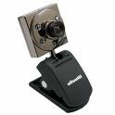

**E)Make suggestion for them.(3x2=6)**

Shall we go to the market? Why don’t you go to the market? What about turning on the central heating?

There is nothing in the fridge

I have a toothache

[](http://www.google.com.tr/imgres?imgurl=http://www.holidayinsights.com/moreholidays/February/toothache.jpg&imgrefurl=http://www.holidayinsights.com/moreholidays/February/toothacheday.htm&usg=__yLLW_X4JXqEDL_BP-guGamaHEK0=&h=350&w=161&sz=26&hl=tr&start=5&um=1&itbs=1&tbnid=tPhEmaHMbvY-WM:&tbnh=120&tbnw=55&prev=/images?q=toothache&tbnid=IIC2xk1Tq9JxxM:&tbnh=0&tbnw=0&um=1&hl=tr&sa=X&rlz=1R2WZPA_en&imgtype=i_similar&tbs=isch:1)

I’m cold

[](http://www.google.com.tr/imgres?imgurl=http://images.clipartof.com/small/33821-Clipart-Illustration-Of-A-Cold-Penguin-Mascot-Cartoon-Character-In-A-Hat-And-Scarf-Shivering-And-Surrounded-By-Blocks-Of-Ice.jpg&imgrefurl=http://www.clipartof.com/details/clipart/33821.html&usg=__eeJ61eMWE4KLEculGeVtlXECH00=&h=351&w=450&sz=59&hl=tr&start=1&um=1&itbs=1&tbnid=gpt5DK07i97ccM:&tbnh=99&tbnw=127&prev=/images?q=cold+cartoon&tbnid=gpt5DK07i97ccM:&tbnh=0&tbnw=0&um=1&hl=tr&sa=X&rlz=1R2WZPA_en&imgtype=i_similar&tbs=isch:1)

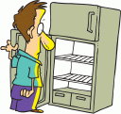

\_\_\_\_\_\_\_\_\_\_\_\_\_\_\_\_\_ \_\_\_\_\_\_\_\_\_\_\_\_\_\_\_\_\_\_

\_\_\_\_\_\_\_\_\_\_\_\_\_\_\_\_\_\_\_\_\_

**F.MATCH THE WORDS WITH THEIR MEANING ( 4\*1=4 )**

1. Electronic message

2.first page of a website

3.http://www……….com is an example of

4.a network of computers

a) internet 1.

b) a URL 2.

c) e-mail 3.

d) homepage 4.

**G)READ THE TEXT AND FILL IN THE SPIDERGRAM(8\*2=16)**

We use the internet to find information for our homeworks and our hobbies,sports and music.

We use internet to read newspapers and books.We can play computer games.You can buy things.We can send e-mails.

**H)CHOOSE THE CORRECT ONE?(8x2=16)**

1. Ayşe’nin cevabına göre Ahmet ne sormuş olabilir?

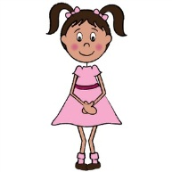 Ahmet: …………..………..……

Ayşe : I’m a Leo.

a) How are you today?

b) What is your sun sign?

c) Do you believe in horoscopes?

d) When is your birthday?

1. [](http://www.google.com.tr/imgres?imgurl=http://www.servitokss.com/wp-content/uploads/2009/07/man_question_mark.jpg&imgrefurl=http://www.servitokss.com/question-marks/&h=359&w=286&sz=11&tbnid=RtcmX_DtJpu3_M:&tbnh=90&tbnw=72&prev=/search?q=question+mark&tbm=isch&tbo=u&zoom=1&q=question+mark&usg=__ful61j3IGjmH6RiaDIX7vIbadjo=&docid=eMyx6Jx8vgTqXM&hl=tr&sa=X&ei=Ze-oUI_4Joix0AWRrYHIBg&ved=0CC4Q9QEwAQ&dur=2533)What is your lucky number?

a) It is on 10 th of March.

b) I believe in horoscopes.

c) It is 9.

d) I am a sagittarious.

3. We should …………… cans, bottles and newspapers to help our environment.

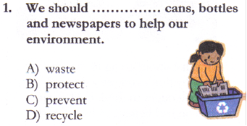a) waste

b) protect

c) prevent

d) recycle

[](http://www.google.com.tr/imgres?q=air+pollution&hl=tr&rls=com.microsoft:tr:IE-SearchBox&biw=1117&bih=574&tbm=isch&tbnid=Gqk7hkisXFw03M:&imgrefurl=http://amudu-gowripalan.blogspot.com/2011/07/air-pollution.html&docid=AGYninnUK_l0wM&imgurl=http://4.bp.blogspot.com/_SyIiNJJYnCM/TQBSg_JE-HI/AAAAAAAAABg/hNd-923TiwE/s1600/pollution.jpg&w=613&h=475&ei=xhGsTtPJD4L_4QTs_8SODw&zoom=1&iact=rc&dur=16&sig=115104000095747409096&page=4&tbnh=158&tbnw=205&start=27&ndsp=10&ved=1t:429,r:1,s:27&tx=111&ty=8)

4.

1. Water pollutıon
2. Environment pollutıon
3. Aır pollutıon
4. Recycle

5)My grandmother lives in the countryside. She likes nature. She has a lot of farm animals.

a) Urban life b) Rural life

6) Mehmet’s motorbike is………… … Murat’s motorbike .

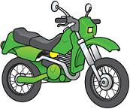

a) different c) different than

b) the same as d) different from

7. Yanlış olanı bul.

[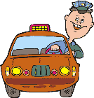](http://www.signsbyyou.com/decals/vinyl-decal-388181.htm)

190 km/h 170 km/h

18.000 TL 15.000 TL

1. Faruk’s car is cheaper than Ferit’s car.
2. Ferit’s car is faster than Faruk’s car
3. Faruk’s car is more expensive than Ferit’s car.
4. Faruk’s car is slower than Ferit’s car

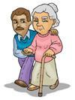8) Ahmet’s uncle is a good man and he likes helping the old.

A) He is a stingy person.

B) He is a very funny person.

C) He is a very helpful person.

D)He is a very serious person