**2012-2013** **ACADEMIC YEAR AYŞE FITNAT SECONDARY SCHOOL FIRST TERM SECOND ENGLISH EXAMINATION FOR 4TH GRADES**

**NAME / SURNAME(ad-soyad): CLASS / NUMBER(sınıf-numara):**

**A- Boşlukları ‘have got’ veya ‘has got’ kullanarak doldurunuz(5x 2 =10)**

1. I…………………………………a sister
2. She…………………………………a cat
3. You………………………………one uncle .
4. They……………………………….two books.
5. My mother ……………….. a blue dress.

**B-Aşağıdaki resime bakarak boşluklara doğru kelimeleri yazın.(7x2=14)**

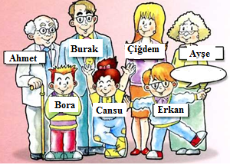1- Hi ! My name’s Erkan.

2-Cansu is my ……………………………..

3-Bora is my …………………………..

4-Çiğdem is my ………………………….

5-Burak is my …………………………….

6-Ayşe is my ……………………………

7- Ahmet is my ……. .………………………

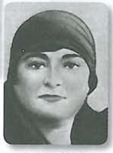 **C- “His” veya “Her” kullanarak boşlukları dolduralım. ( 4x2=8 )**

______name is Zübeyde Hanım.

---------  
Zübeyde Hanım

_______name is Makbule Hanım.

----------

______name is Mustafa Kemal ATATÜRK.

_______name is Ali Rıza Efendi.

----------- name is  
Ali Rıza Efendi

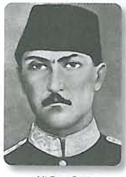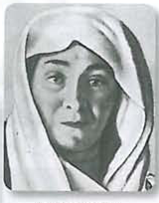

**D- Sorularla cevapları eşleştiriniz.(5x2=10)**

1. What is her name? _______                              a)  It is a desk.

2.What is his name? ________                             b) They are pencil sharpeners.

3.What is that?  _________                                    c) Her name is Neslihan.

4.What are those?  _________                              d) It is a bag.

5.Is that a desk or a table?  ________                 e) His name is Arda.

**E-** **Aşağıdaki cümleleri doğru resimlerle eşleştirin. (5x2=10)**

1. Sit down. **b)** Write **c)** Be quiet! **d)** Open your book. **e)** Close the door.

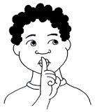  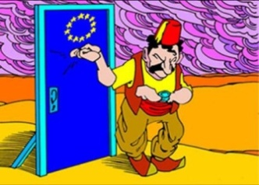 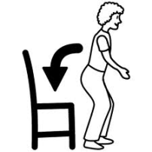

…… ……… ……… …… ……

**F- Rakamların İngilizce Karşılığını Yazınız.(10x1=10)**

**1:_________ 4:_________ 7:__________ 10:___________**

**2:__________ 5: _________ 8: _________**

**3: _________ 6: _________ 9: _________**

**G-Resimlerin altına kelimelerin anlamlarını yazınız(10x2=20)**

**(belt, cap, skirt, trousers, shirt, gloves, shoes, slippers, T-shirt, coat)**

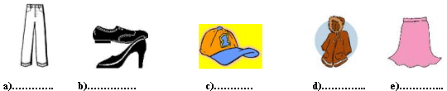

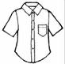[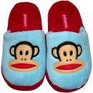](http://images.google.com.tr/imgres?imgurl=http://www.psychobabyonline.com/site/scpics/tmb/1391/slippers.jpg&imgrefurl=http://www.psychobabyonline.com/paul-frank/&usg=__Mx3MmVNauIWmd7d3srZVD62288g=&h=500&w=500&sz=105&hl=tr&start=5&tbnid=ZC4kIEKz76bsGM:&tbnh=130&tbnw=130&prev=/images?q=slippers&gbv=2&hl=tr)[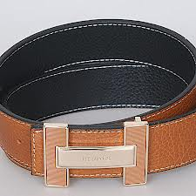](http://www.google.com.tr/imgres?q=deri+kemer&hl=tr&sa=X&tbo=d&rlz=1W1ADFA_trTR460&biw=1366&bih=576&tbm=isch&tbnid=XLlqGKz7tbIu6M:&imgrefurl=http://www.inthemoda.com/hermes-erkek-deri-kemer-kahve-p-1452.html&docid=nZsGmNiEyHuK_M&imgurl=http://www.inthemoda.com/imaj/2-hermes-belt-brown.jpg&w=450&h=450&ei=sY-_UJL0Icn34QSfz4GIDA&zoom=1&iact=hc&vpx=2&vpy=233&dur=2181&hovh=225&hovw=225&tx=41&ty=132&sig=107549370648137800998&page=2&tbnh=126&tbnw=128&start=14&ndsp=36&ved=1t:429,r:18,s:14,i:238)[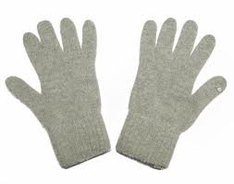](http://www.google.com.tr/imgres?q=eldiven+resmi&hl=tr&tbo=d&rlz=1W1ADFA_trTR460&biw=1366&bih=576&tbm=isch&tbnid=hliLFJg-0ytHWM:&imgrefurl=http://urun.gittigidiyor.com/giyim-aksesuar/t-glove-f120so-bayan-ang-sol-dokunmatik-eldiven-24907377&docid=KtNIBDz8jqLRiM&imgurl=http://images.gittigidiyor.com/2490/t-glove-F120SO-Bayan-Ang-Sol-Dokunmatik-Eldiven__24907377_0.jpg&w=700&h=553&ei=YJC_UOviBrSK4gTXg4D4AQ&zoom=1&iact=hc&vpx=846&vpy=110&dur=929&hovh=199&hovw=253&tx=77&ty=122&sig=107549370648137800998&page=1&tbnh=115&tbnw=151&start=0&ndsp=30&ved=1t:429,r:7,s:0,i:101)

**f)................. g).................. h)..................... i)....................... j)....................**

**H- Aşağıdaki renklerin karşısına Türkçe anlamlarını yazınız. (10x2=20)**

|  |  |  |  |
| --- | --- | --- | --- |
| **Yellow** |  | **White** |  |
| **Black** |  | **Pink** |  |
| **Green** |  | **Purple** |  |
| **Blue** |  | **Red** |  |
| **Orange** |  | **Brown** |  |

[](http://www.google.com.tr/imgres?q=good+luck&hl=tr&tbo=d&rlz=1W1ADFA_trTR460&biw=1366&bih=576&tbm=isch&tbnid=GByNd6jwVUxp1M:&imgrefurl=http://friends18.com/category/good-luck/&docid=dqBOTvrxvVZ-SM&imgurl=http://friends18.com/img/good-luck/066.jpg&w=225&h=177&ei=m5W_UNPQPOmL4gS1p4CgBw&zoom=1&iact=hc&vpx=531&vpy=198&dur=3043&hovh=141&hovw=180&tx=65&ty=74&sig=107549370648137800998&page=2&tbnh=123&tbnw=156&start=14&ndsp=36&ved=1t:429,r:4,s:14,i:155)